RIC-APA 35th Anniversary Celebration

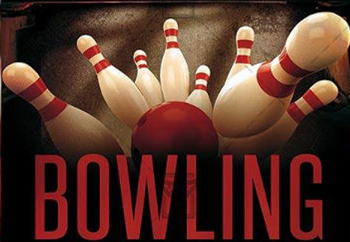
. --------------------- 9.18.19 ----------------------

19
939 Myers St. Richmond, VA 23230
nd, VA 23230

You’re invited to celebrate APA Richmond’s 35th anniversary at River City Roll
Open to the first 75 members to register at apa-richmond.com
ENJOY
- Bowling (8 lanes reserved)
- Food
- Drinks (2 alcohol tickets per member)
- Music
- Networking

6pm – 9pm

